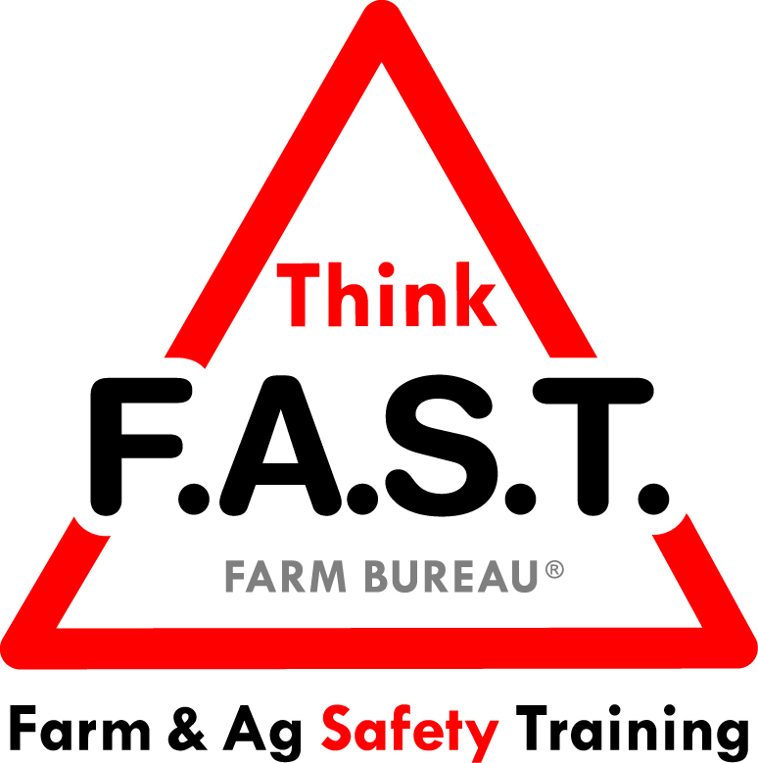

Module 3: Critical Thinking with Tractor and Equipment Safety

Objectives:
- The learner will understand how our ability to think critically about situations is biased by our experiences.
- The learner will understand that critical thinking requires looking at a situation from more than one point of view.
- The learner will demonstrate awareness and comprehension of tractor and equipment safety skills.

Time Required:
- Approximately 40 minutes

Materials & Set-Up:
- Pens and paper or something to write on – per individual
- Regionally appropriate tractor and/or piece of large equipment
  - Optional: More than one tractor and/or equipment available.

Lesson:

Introduction
- To engage youth, ask them write down a current event on a piece of paper. This can be something they saw on the news, through social media, heard in conversation, etc.
- Ask them to briefly write (1-2 sentences) their point of view of the event/situation. When they are finished, have them pair up with one other participant and exchange papers. Then they will write their point of view of their partners’ event. Once finished, have them compare and contrast their points of view.
- Remind them that our point of view is often biased by our circumstances, and that there are multiple points of view. Critical thinking requires looking at situations through more than one “lens.”
- Preview that today’s focus is on tractors and equipment, and the importance of safe assessment and handling. Note that critical thinking is crucial when considering routine and emergency situations with large equipment.

Suggested Skill Building Activities:
*Note: Instructor may modify for time and regionally-appropriate content, as long as safety and core skills are adequately addressed.

- Thinking Critically
  - On a piece of paper, ask youth to draw two circles side by side, representing looking through binoculars.
    - Example:

  - Ask them to write down a task they do around home or in an agricultural setting at the top of the paper.
    - Example: Watering the plants at the greenhouse.
  - On the left hand side of the paper, have them write three words horizontally: efficient, better, safe
  - Using the space inside the “binoculars,” have them write or draw representations of what the task looks like through each “lens.” (efficient, better, safe)
  - Ask for examples from the group and discuss. Make note that just because a task has always been done a certain way doesn’t mean that there aren’t better ways to do it.
    - As time allows, discuss personal examples.

Core skill: We have to be able to look at tasks through different “lens” using critical thinking skills in order to determine the best plan of action. Just because a task has always been done a certain way does not make it the best way to complete it.
Indicators of activity success:
- Through active participation, learners are engaged in thoughtful responses to their critical thinking task.

- Operating Principles
  - Have youth gather around the tractor/equipment. Give background on equipment if necessary. Have youth respond and discuss the following questions:
    - What should you be aware of prior to operating the tractor or equipment?
      - Answer:
        - Engineering controls (guards, ROPS, seatbelts, special machine functions)
        - Education (do you know how to use this equipment, have you received proper training)
        - Enforcement (state laws, OSHA regulations, farm or workplace specific rules)
    - What is the purpose of an operator’s manual? Give a practical example of how you could use the manual.

Core skill: Understanding the equipment, its function, and safety features is imperative to safe operation.
Indicators of activity success:
- Through active participation, learners demonstrate knowledge or desire to learn about operating principles.

- Safety Sequence
  - Have youth pair up. In their team, they are to think of a common situation with tractors/equipment that would require them to think safely about an operating sequence.
    - Example: Baling hay and the intake feeder becomes clogged.
  - In teams, they will discuss or write out the safest sequence of steps to fix the problem.
  - Have a few teams share their problem and safe solution.

Core skill: Being able to think about problems and solve them with safe steps is key to successful operation of tractors and equipment.
Indicators of activity success:
- Through active participation, learners demonstrate knowledge of appropriate and safe procedures while working around tractors and/or equipment.

Reflection Questions
- To close out the lesson, ask youth the following questions, and allow for individual or group discussion:
  - What is one change you are going to make regarding your interactions around equipment after this training?

Challenge
- The next time you work with a tractor or large piece of equipment consider the risks of possible injury. Think about how lives would be changed because of an unsafe encounter with equipment. Slow down, and use your critical thinking skills to help assess potentially dangerous situations prior to getting on to the equipment.

Additional Resources:
- Marshfield Clinic, North American Guidelines for Children’s Agricultural Tasks (see “Tractor Fundamentals” and “Implement Operations” http://www.nagcat.org/nagcat/?page=nagcat_guidelines_posters

